Both of the below pages can be modals. Users can just copy and paste my email address to contact us or ask questions

**Help**

New to Findbball? Start with our How it works video below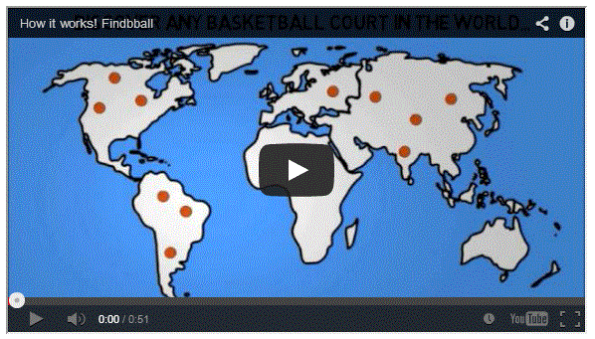

For additional questions, email [info@findbball.com](mailto:info@findbball.com)

**Contact us:**

For additional questions or to contact us, email [info@findbball.com](mailto:info@findbball.com)